**Control Instruction**

Program is a set of instructions. We know that each instruction of the program is executed by processor. Processor executes instructions one by one. Whatever we write in our program is executed in the same order as they appear in the program. We can say processor executes instructions in a sequential manner. At a particular instant processor is executing some line of code, we say control of processor is on that line. Processor’s control moves from one line to another. This movement of control is known as flow of the program.

Sometimes, it is required that the program’s flow shouldn’t be sequential. For example, we want to execute first line of our program, then second and third line but after executing third line, we may want to skip fourth line and jump to the fifth line. In such situations, we use control instructions. Control instruction gives power to decide the flow of the program.

Try to understand

#include<stdio.h>

Int main()

{

Line 1;

Line 2; # Program is a set of instructions. We know that each instruction of the program is executed by

Line 3; processor. Processor executes instructions one by one and we can say processor

Line 4; executes instructions in a sequential manner..

Line 5; # When processor execute will be the first line of our program . so we can say that

} now control of processor is on first line.

There are four types of control instructions:

* Decision control instruction/ conditional statement
* Iterative control instruction
* Switch case control instruction
* Goto instruction

Decision control instruction

Decision control instruction is also known as selection control instruction. C language provides three ways to implement this instruction:

In all conditional statement we can’t write in word because this type of function work on only arithmetic operation. Ex if(three>four) not valid

if(3>4) is valid.

1. if
2. if else
3. Conditional operator (C Short Hand If Else)
4. Nested if else
5. If else ladder

**Note**

Conditional operator is more faster and take less time to execute compare to if and if else statement Because conditional operators has less action statement compare to both statement.

Note :- Conditional Statement work on condition as well as Expression

## If statement.

Following is the syntax of if statement:  
  
int main()  
{  
 ..…  
 …..  
 if(some condition / expression)

This block is known as if block and count as one action statement. Whatever we write in if block will be execute only when condition is TRUE. When condition is false control skip from the if block and execute statements written after if block.

{   
 Statement2;

Statement2;   
 }   
}

**Note**

* No need to use open and close curly brackets if one statement written in if block condition
* Else always comes after if block.
* ; is used for terminate the statement.

## if else statement

Following is the syntax of if else statement:  
int main()  
{  
..…  
 if(some condition)  
 {   
 Statement1;  
 Statement2;  
 ….  
 }  
 else  
 {  
 Statement1;  
 Statement2;  
 ….  
 }  
}

This block is known as if else block and count as one action statement. Whatever we write in if block will be execute only when condition is TRUE. When condition is false control skip on the if block and execute statements written else block.

## Conditional Operator ( ?: )

Conditional operator is the only operator in C language which requires three operands, hence known as ternary operator. Following is the syntax of conditional operator:  
Expression1 ? expression2 : expression3;

Expression 1 is condition, evaluated as true or false. When expression 1 is true expression 2 is selected otherwise expression 3 is selected.

Example

#include<stdio.h>

void main()

{

*// w.a.p to check given number is positive or not.Using if and else statement.*

    int x;

    printf("Enter a number");

    scanf("%d",&x);

*/*if(x>0)*

*{*

*printf("Given number is positive");*

*}*

*else*

*printf("Given number is negative");*/*

*// w.a.p to check given number is positive or not.Using conditional operator statement.*

         x>0?printf("Given number is positive"):printf("Given number is negative");

}

## Nested if else

When if-else statements written in if block or else block, it is called nested if-else  
Example: Program to print greater among three numbers

Syntax

Multiple line statement Single line statement

if(Some Condition) if(Some Condition)   
{ {  
 if(Some Condition) if(Some Condition)

{ statement;

statement1; else  
 statement2 statement;

} }  
 else else

{ {   
 statement1; if(Some condition)  
 statement2; statement;  
 } else  
else statement;  
{ }  
 if(Some Condition)

{

statement1;  
 statement2

}  
 else

{  
 statement1;  
 statement2;  
 }  
}

## If else ladder

Else if ladder is nothing but a special case of nesting where if else resides only in else block.  
Syntax of else if ladder:  
  
if(Some Condition)  
{

statement1;  
statement2;  
}  
else if(Some Condition)

{  
statement1;  
statement2;  
}  
else if(Some Condition )  
{  
statement1;  
statement2;  
}  
else  
{

statement1;  
statement2;  
}  
Note

* We can write multiple if else condition in if and else block..
* Only one block is selected for execution..
* If else ladder is nothing but a special case of nesting.

**Questions**

* *W.A.P to check given number is positive or not. Using conditional operator statement , if statement and if else statement.?*
* *W.A.P to check number is positive , negative or non positive and non negative  using if else ladder.?*
* *W.A.P to check given number is odd or even. Using conditional operator statement , if statement and if else statement.?*
* *W.A.P to check given number is divisible by 5 or not. Using conditional operator statement , if statement and if else statement.?*
* *W.A.P to check grater number among two number .Using selective statement of conditional operator statement , if statement and if else statement.?*
* *W.A.P to print which one is grater among three number using nested if else and nested conditional operator.?*
* *W.A.P to calculate grade of student according to marks at least of 4 subject using if else ladder and print final result of student?.*
* *If you give any year is input through the keyboard . write a program to determine whether the year is leap year or not.?*
* *Take integer input and print the absolute value of that integer value.?*

*( The absolute value change the negative sign the absolute value of 5 is 5, and the*

*absolute value of −5 is also 5.*)*

* If the cost price and selling price of an item is input through the keyword . write a program to determine whether the seller has made profit and incurred loss. Also determine how much profit he made or loss he incurred ?

(we know that profit = when SP>CP and Loss =when CP>SP )

* Given the length and breadth of a rectangle , W.A.P to find whether the area of the rectangle is greater than its perimeter or not?

Area of rectangle = Length * width

Perimeter of Rectangle = 2 (Length + width)

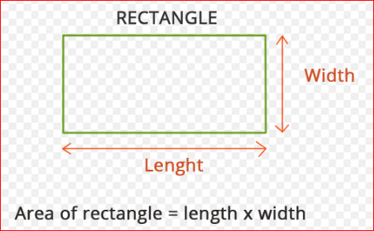

**Multiple conditions using && and || operators**

* Take a positive integer input and print given number is three digit number or not or not.
* take tow two digit number and print how many number between them
* Take a positive integer input and print given number is divisible by 3 and 5 ?
* Take a positive integer input and print given number is divisible by 3 or 5 ?
* Take two positive integer input and print how many number between them is divisible by 3 and 5?
* Take 3 input from user and print given input is sides of triangle?

(we know that side of triangle if a+b>c, b+c>a and c+a>b all condition is satisfy)

* If the age of Ram , Mohan and Ajay are input through keyword , W.A.P to determine who is youngest ?s
* Given three points (x1, y1), (x2, y2) and (x3, y3), write a program to check if all the three points fall on one straight line.

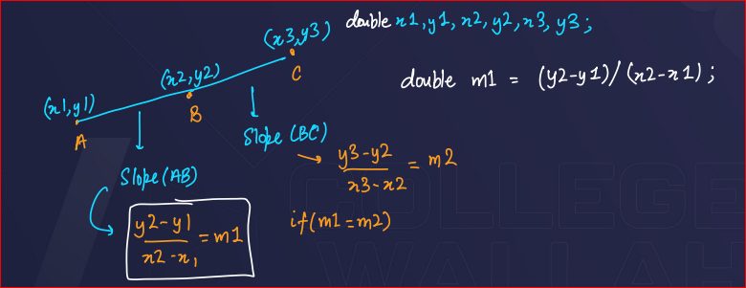

* Given a point (x, y), write a program to find out if it lies on the x-axis, y-axis or at the origin, viz. (0, 0).
* if(x==0 && y==0)
* printf("The point lies on Origin");
* else if(x==0)
* printf("The point lies on Y-axis");
* else
* printf("The point lies on X-axis");
* 

